FOODSERVICE PRODUCT GUIDE 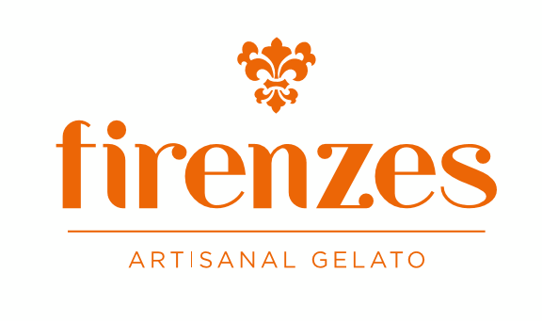
- Prepackage 6 oz individually cup
Gelatos  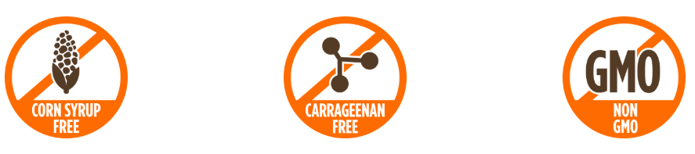 | Sorbets
o Coconut | o Passion Fruit
o Lucuma | o Mango
o Chirimoya | o Guava
o Dark Chocolate | o Strawberry
o Tiramisu
o French Vanilla

- 1.5 Gallon Gelato pans
Gelatos
o French Vanilla | o Lucuma
o Sea Salt Caramel | o Ferrero Rocher
o Dark Chocolate | o Cookies & Cream
o Blueberry Cheesecake | o Mint Oreo
o Butter Pecan | o Peanut Butter Oreo
o Coconut | o Hazelnut
o Stracciatella | o Horchata de Morro
o Cinnamon | o Pistachio
o Cappuccino | o Key lime pie
o Nutella | o Chirimoya

Sorbets

o Passion Fruit | o Guava
o Avocado | o Strawberry
o Mango | o Tripe Berry
o Lemon | o Basil Pineapple
o Pink Grapefruit | o Mojito

